**Year 2018**

**VCE**

**Mathematical Methods**

**Trial Examination 2**

**Solutions**



|  |  |
| --- | --- |
| **KILBAHA MULTIMEDIA PUBLISHING**  **PO BOX 2227**  **KEW VIC 3101**  **AUSTRALIA** | **TEL: (03) 9018 5376**  **FAX: (03) 9817 4334**  **kilbaha@gmail.com**  **http://kilbaha.com.au** |

IMPORTANT COPYRIGHT NOTICE

1. This material is copyright. Subject to statutory exception and to the provisions of the relevant collective licensing agreements, no reproduction of any part may take place without the written permission of Kilbaha Multimedia Publishing.
2. The contents of this work are copyrighted. Unauthorised copying of any part of this work is illegal and detrimental to the interests of the author.
3. For authorised copying within Australia please check that your institution has a licence from **Copyright Agency Limited**. This permits the copying of small parts of the material, in limited quantities, within the conditions set out in the licence.

Reproduction and communication for educational purposes The Australian Copyright Act 1968 (the Act) allows a maximum of one chapter or 10% of the pages of this work, to be reproduced and/or communicated by any educational institution for its educational purposes provided that educational institution (or the body that administers it) has given a remuneration notice to Copyright Agency Limited (CAL) under the Act.

For details of the CAL licence for educational institutions contact

CAL, Level 15, 233 Castlereagh Street, Sydney, NSW, 2000

Tel: (02) 9394 7600

Fax: (02) 9394 7601

Email: [info@copyright.com.au](mailto:info@copyright.com.au)

Web: <http://www.copyright.com.au>

* While every care has been taken, no guarantee is given that these answers are free from error. Please contact us if you believe you have found an error.

**SECTION A**

**ANSWERS**

|  |  |  |  |  |  |  |  |  |  |  |
| --- | --- | --- | --- | --- | --- | --- | --- | --- | --- | --- |
| **1** |  | **A** |  | **B** |  | **C** |  | **D** |  | **E** |
| **2** |  | **A** |  | **B** |  | **C** |  | **D** |  | **E** |
| **3** |  | **A** |  | **B** |  | **C** |  | **D** |  | **E** |
| **4** |  | **A** |  | **B** |  | **C** |  | **D** |  | **E** |
| **5** |  | **A** |  | **B** |  | **C** |  | **D** |  | **E** |
| **6** |  | **A** |  | **B** |  | **C** |  | **D** |  | **E** |
| **7** |  | **A** |  | **B** |  | **C** |  | **D** |  | **E** |
| **8** |  | **A** |  | **B** |  | **C** |  | **D** |  | **E** |
| **9** |  | **A** |  | **B** |  | **C** |  | **D** |  | **E** |
| **10** |  | **A** |  | **B** |  | **C** |  | **D** |  | **E** |
| **11** |  | **A** |  | **B** |  | **C** |  | **D** |  | **E** |
| **12** |  | **A** |  | **B** |  | **C** |  | **D** |  | **E** |
| **13** |  | **A** |  | **B** |  | **C** |  | **D** |  | **E** |
| **14** |  | **A** |  | **B** |  | **C** |  | **D** |  | **E** |
| **15** |  | **A** |  | **B** |  | **C** |  | **D** |  | **E** |
| **16** |  | **A** |  | **B** |  | **C** |  | **D** |  | **E** |
| **17** |  | **A** |  | **B** |  | **C** |  | **D** |  | **E** |
| **18** |  | **A** |  | **B** |  | **C** |  | **D** |  | **E** |
| **19** |  | **A** |  | **B** |  | **C** |  | **D** |  | **E** |
| **20** |  | **A** |  | **B** |  | **C** |  | **D** |  | **E** |

**SECTION A**

**Question 1 Answer C**



 included



 not included, so the domain is 

## Question 2 Answer E



 the remainder is .

## Question 3 Answer D

All of the functions **A. B. C.** and **E.** join up when ,

**D.**  when  gives 

## Question 4 Answer B

 and 

equal gradients when 

There is a unique solution when , Colin is correct.

When  the equations become  and ,

these are multiples, so there is an infinite number of solution when 

When  the equations become  and ,

these are inconsistent, the lines are parallel with different *y* intercepts,

so there is no solution when  Ben is correct.

## Question 5 Answer E



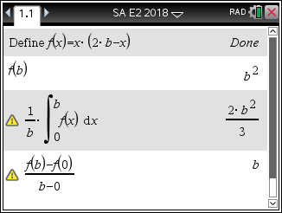**Question 6 Answer D**

 where 

 so the range is  Alan is incorrect.

The average value of the function is 

The average rate of change of the function is , so Ben is correct.

The gradient, since ,  the function is always increasing and that the gradient at an end-point  does not exist, David is correct.

**Question 7 Answer A**

6 B, 5R, total 11, at least one of each colour



**Question 8 Answer A**

The graph has a vertical asymptote at  so .

The graph crosses the *x*-axis when , at a negative value , 

The graph crosses the *y*-axis when , at a positive value



## Question 9 Answer B



**Question 10 Answer D**



  **A.** is true



  **B.** is true

 **C.** is true

 **E.** is true **D.** is false

**Question 11 Answer C**

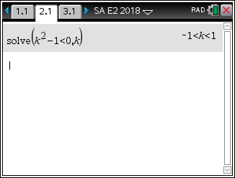 and 





do not intersect when  

## 

## Question 12 Answer E

## 



 take negative since 





## Question 13 Answer B

If  is a non-zero even function, then , the graph is symmetrical about the *y*-axis so . If is a non-zero odd function, then , then , so 

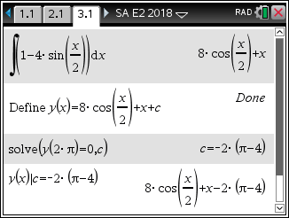**Question 14 Answer B**



to find *c*, 



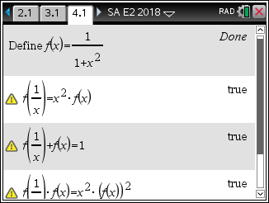

**Question 15 Answer E**

 **A. B. C. D.** are all true

## E. is false

## 

## Question 16 Answer A

The graph of  is transformed into the graph of  since  by

A dilation by a scale factor of  parallel to the *y*-axis, a reflection in the *x*-axis,

and a translation of  to the right parallel to the *x*-axis.

**Question 17 Answer C**

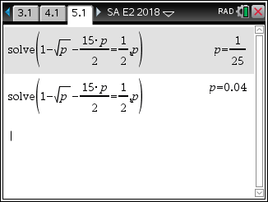 ,  , 

|  |  |  |  |
| --- | --- | --- | --- |
|  |  |  |  |
|  |  |  |  |
|  |  |  |  |
|  |  |  |  |

## 



solving  gives 

## Question 18 Answer D

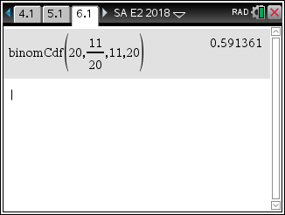 have blue eyes. 

 



## Question 19 Answer C

Given  and 

since , , then





**Question 20 Answer A**



into 

**END OF SECTION A SUGGESTED ANSWERS**

**SECTION B**

**Question 1**

**a.**  the maximum on  is when 

, centre of the circle  A1



 A1

**b.i.**  



 A1



 A1

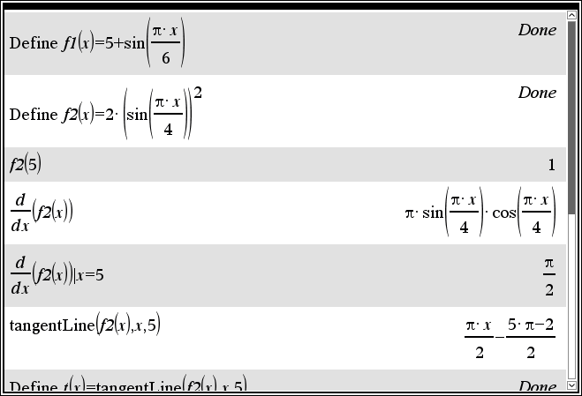

**ii.** solving with  M1



gives 

 A1

**iii.** 

 A1

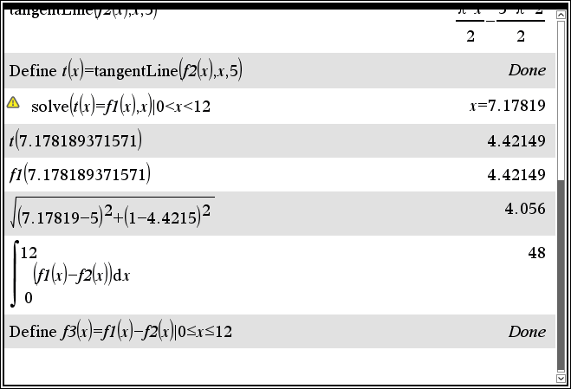

**c.i.** The circular island has a radius of 1 and an area of .

The area of water in the pool is

 A1

**ii.** 

 A1



**d.** 

graphically find the maximum and minimum of *s*, or using  M1

the maximum value of *s* occurs when  and the maximum width is m A1

the minimum value of *s* occurs when  and the minimum width is  m A1

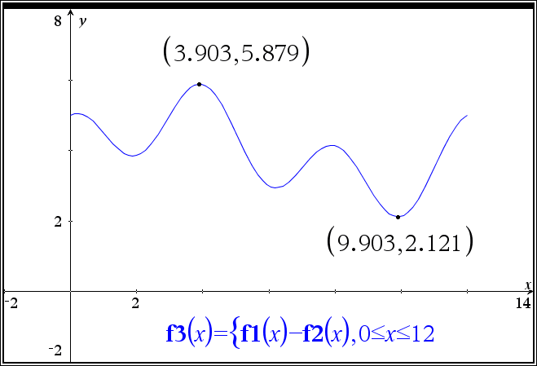

**Question 2**

**a.i. **



 for two stationary points

 A1

**ii.** Given that 



for two stationary points  A1

 M1

so stationary points at  is the maximum turning

and  is the minimum turning point.

The graph crosses the *x*-axis three times if

 and  that is

 A1

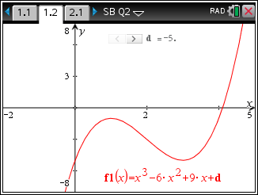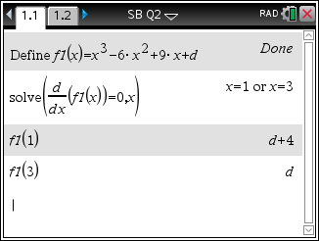

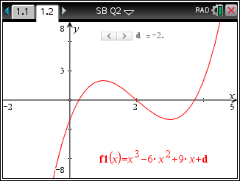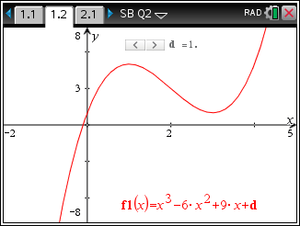

**iii.** If the stationary point is at  then from **a.ii.** 

one stationary point is  so

 and the other stationary point is  A1

**b.i. **

 for one stationary point

 A1

**ii. **

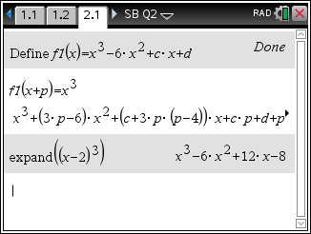 

 M1

equation coefficients



 A1

alternatively 

**c.** crosses the *y*-axis at 

 the tangent is 

so  and 



 the tangent has a gradient of , therefore M1



solving  and  gives  and  or  and  A1

both pairs of answers are acceptable.

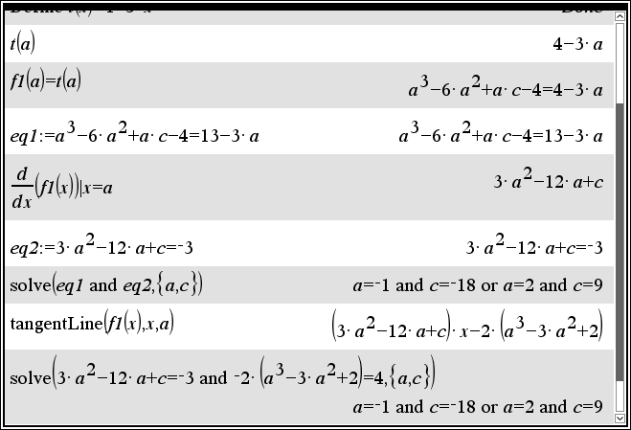

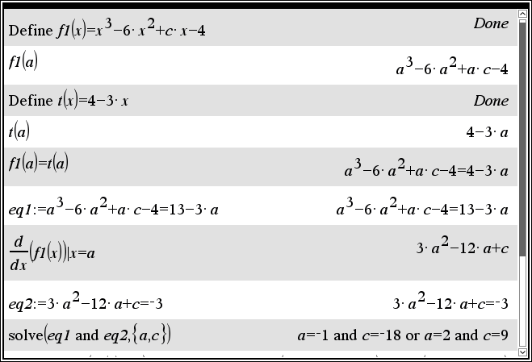

**d.i.** , 

using four equally spaced intervals, 

 A1

 A1

alternatively 



or solving 

 A1

**ii.** stationary points  and the *y*-intercept at  G1

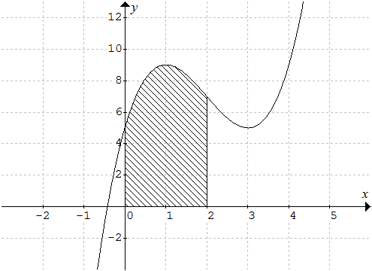

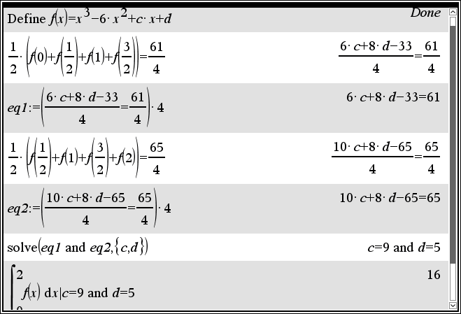

**Question 3**

**a.** Let the burning time in minutes be 

**i.**  A1

**ii.**  A1

**iii.** For the cake 

 A1

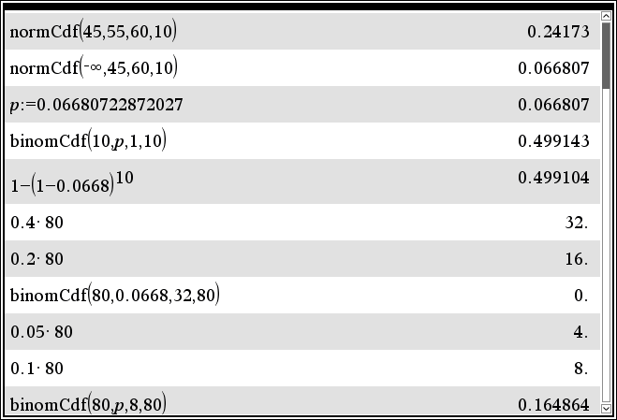

**b.i.**  

 M1



 A1

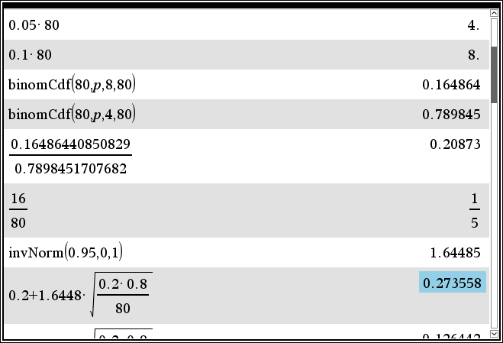

**ii.** 



 A1

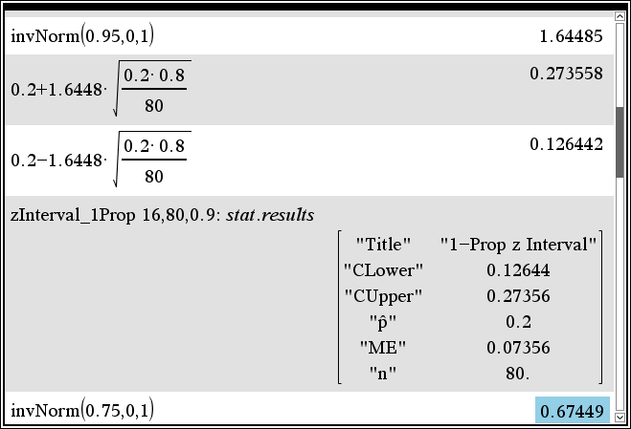

**c.** long life candles 

 M1

 A1

solving  gives  minutes A1

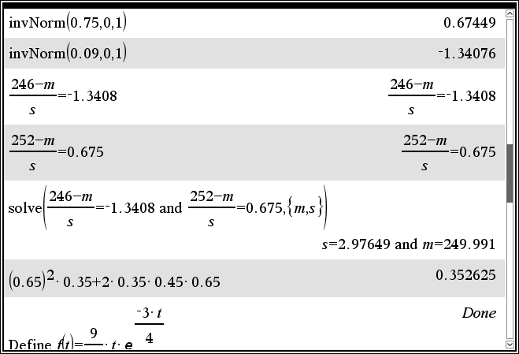

**d.** *I* ice-cream cake, *C* chocolate cake



 M1



 A1

**e.i**  M1

 A1

**ii.**  A1





 A1

**iii.** Solving  gives  A1

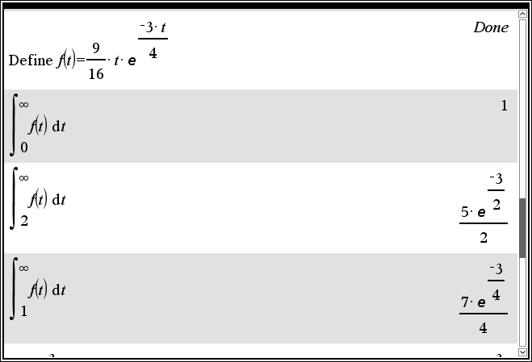

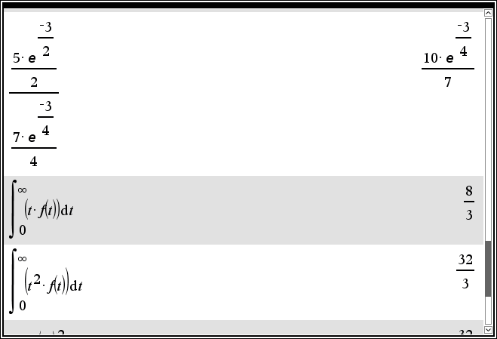

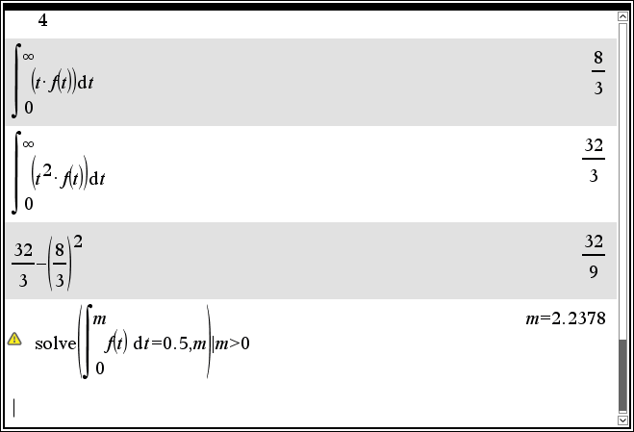

**Question 4**

**a.** maps onto 

 M1



  A1

**b.** 

 A1

**c.** 

 M1

but 

 A1

**d.** solving  or  or , with 

it is easiest to solve 



 so  but 

 A1

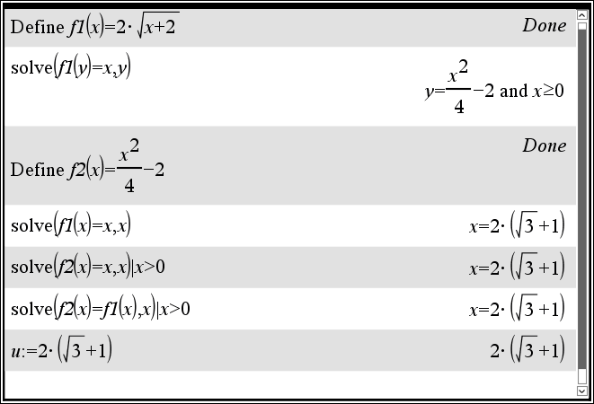

**e.** G2

*f*

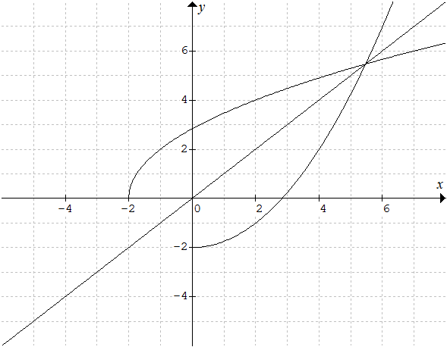



**f.i.** 

 A1

**ii.** 

 A1

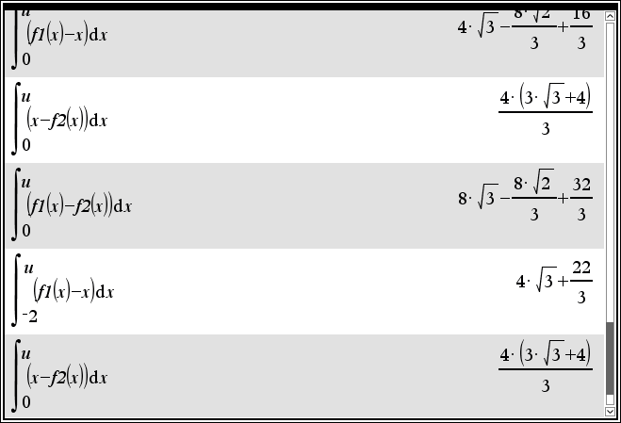

**g.** 

 A1





or alternatively 

 A1

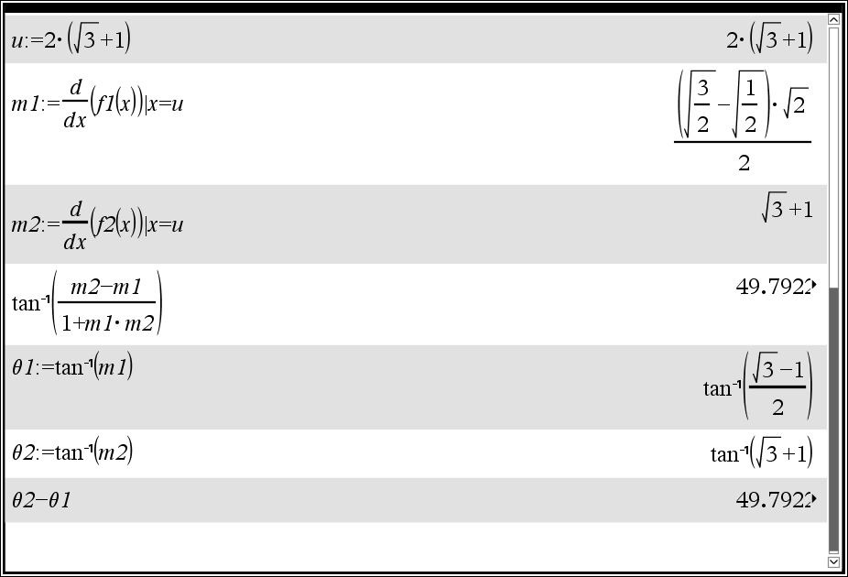

**h.** a translation of *k* units to the left parallel to the *x*-axis, or away from the *y*-axis

and a dilation by a factor of *k*, parallel to the *y*-axis or away from the *x*-axis. A1

**i.** 



but 

 A1

**j.** solving  or  or , with  gives

 A1

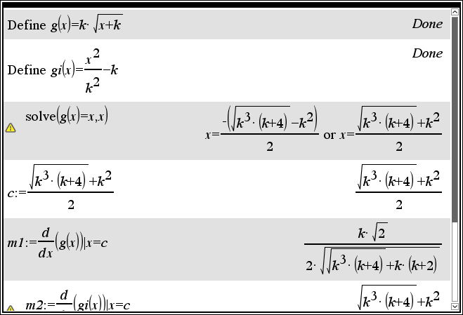

**k.**  A1

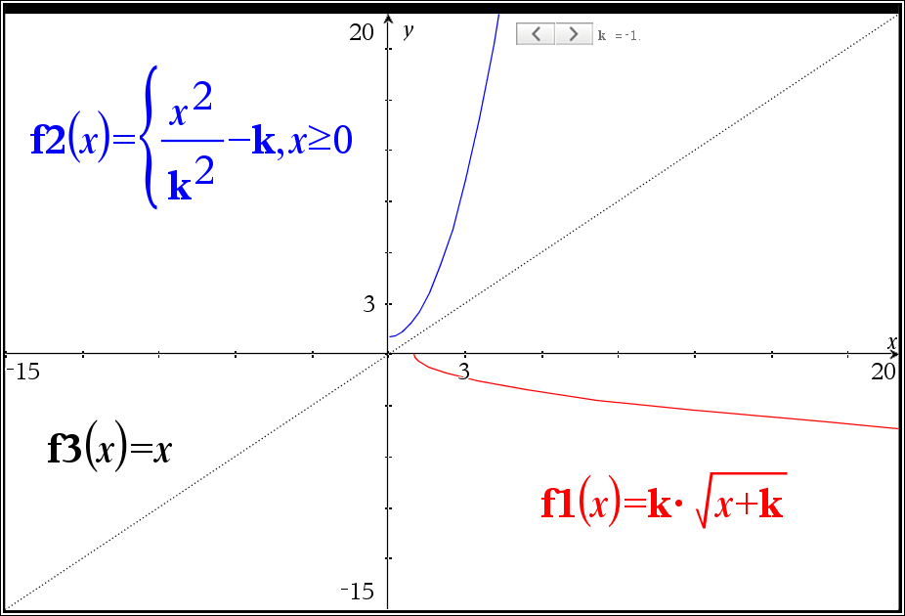

**l.** Let  when  and  when  M1

given  solving  for *k*, with 

as the graphs do not intersect when  gives

 A1

or alternatively , solving  for *k*

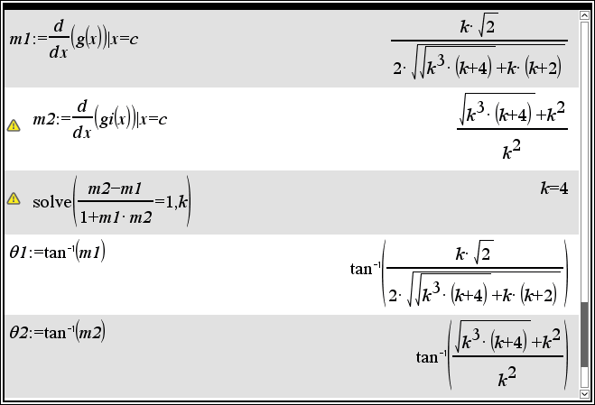

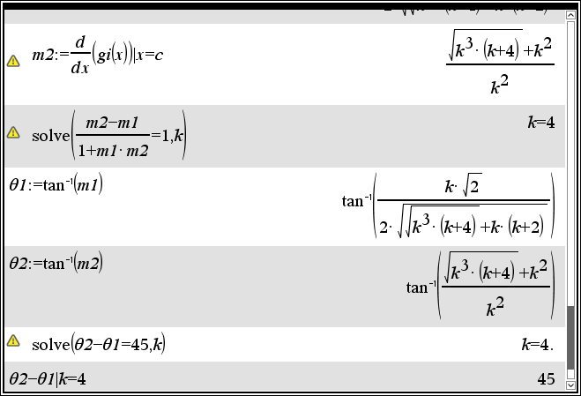

**END OF SECTION B SUGGESTED ANSWERS**